MUZEUL NATIONAL BRUKENTHAL
Piaţa Mare , Nr. 4 - 5
550163 - SIBIU

ROMANIA
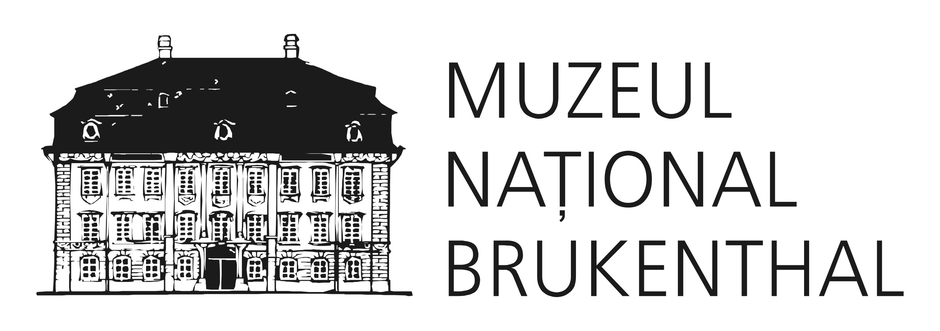
Tel : (+40) 269 217691, 0369/101780 Secretariat
Fax: (+40) 269 211545
E-mail: info@brukenthalmuseum.ro
Pagina web: www.brukenthalmuseum.ro
0269/218143 - MUZEUL DE ISTORIE CASA ALTEMBERGER
0369/101782 - MUZEUL DE ISTORIE NATURALĂ
0369/101783 - GALERIA DE ARTĂ CONTEMPORANĂ
0369/101784 - MUZEUL DE VÂNĂTOARE AUGUST VON SPIESS
0269/218191 - MUZEUL DE ISTORIE A FARMACIEI

PEER REVIEW PROCESS

The manuscript is submitted to the editorial board of the scientific journal Brukenthal. Acta Musei. The editor in chief assigns an associate editor for each of the four domains (History and Archaeology, Art and Art history, Natural History, Restoration and preservation) who decides if the article generally fits the profile of the targeted journal. In the second stage, the article will be send to two other reviewers that belong to the scientific community and have the topic as their research background. Within seven days the researchers have to decide whether they accept the manuscript for reviewing. If one of the reviewers does not agree to review the article, another peer reviewer is assigned by the editor. Within a month, the peer reviewer will review the paper and make a personal decision towards publishing. The reviewer has to take into account four main aspects of the paper:
- The relevance of the topic
- Originality and results
- Scientific approach
- Sustainability
Each of the above mentioned items will be appreciated from 5 to 1 points.

In conclusion the two reviewers make recommendations as follows:
1. the paper is to be accepted in the actual form
2. the paper is to be accepted with extensive or minor revisions
3. the paper is to be rejected.
The final decision concerning the acceptance or rejection of an article will be made by the editor though, based on the evaluation of the peer reviewers and his own.

Note: It is the decision of the peer reviewers if they want to disclose their identity or remain anonymous.

Evaluation form for the peer reviewers
BRUKENTHAL. ACTA MUSEI
Adresa de contact:
Muzeul Naţional Brukenthal, Piaţa Mare, nr 4-5, Sibiu, România, 550163; Editor in chief: Prof.Dr. Sabin Adrian LUCA, sabin.luca@brukenthalmuseum.ro .
Web site: http://www.brukenthalmuseum.ro/publicatii/01.htm
Reviewer’s Name:
Affiliation:
Date:
Manuscript number:
Title:
Authors:

- The relevance of the topic
5-Exceptional, 4- Significant, 3-Minor, 2-Questionable, 1-None or not suitable
Comments*: ……………………

2. Originality and results (comments)
5-Exceptional, 4- Significant, 3-Minor, 2-Questionable, 1-None or not suitable
Comments*: …………………

3. The scientific approach
5-Exceptional, 4- Significant, 3-Minor, 2-Questionable, 1-None or not suitable
Comments*: ………………………

4. Recommendations to author(s)
(Template, language, style, graphical materials, mathematics etc)
Note: any correction can be made directly on the text in red pen.

5. Conclusions
For publication ⁭
For publication after the paper has been reviewed ⁭
Rejected ⁭

* The comments should comprise 5 to 10 rows for each main aspect of the paper.

